**Generic Board:**

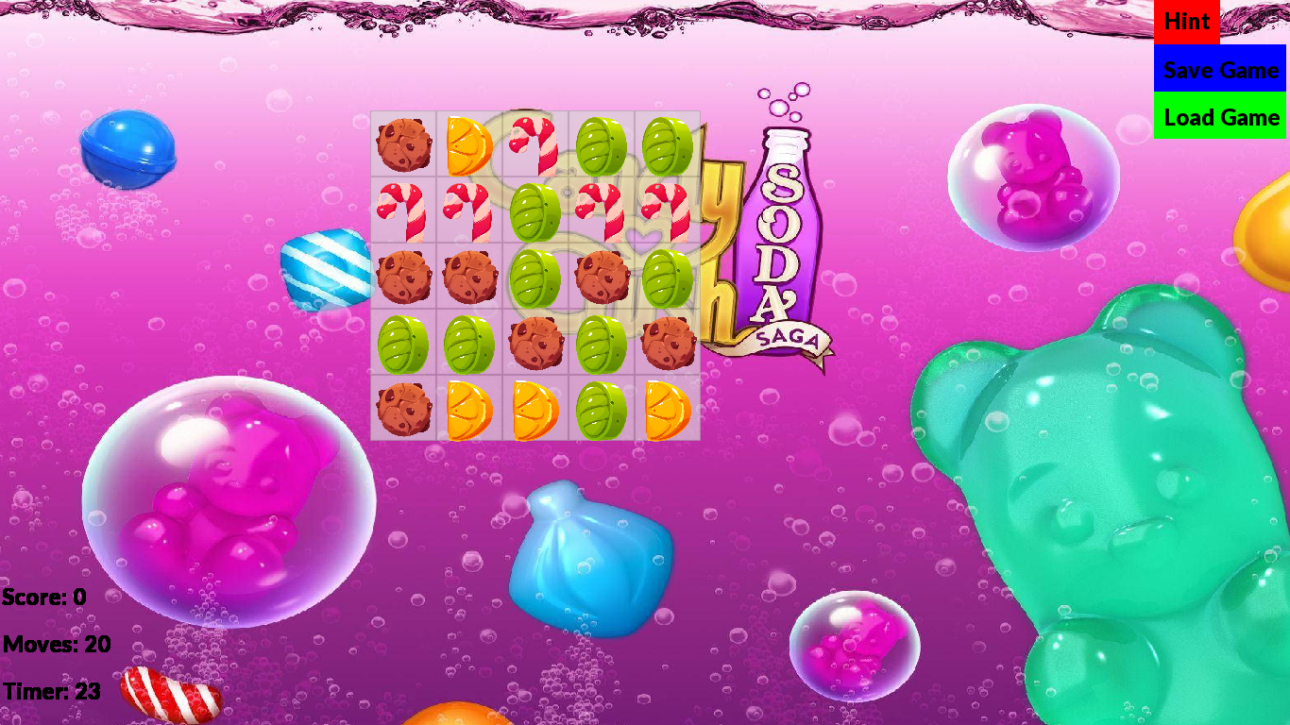**Initialize grid:**

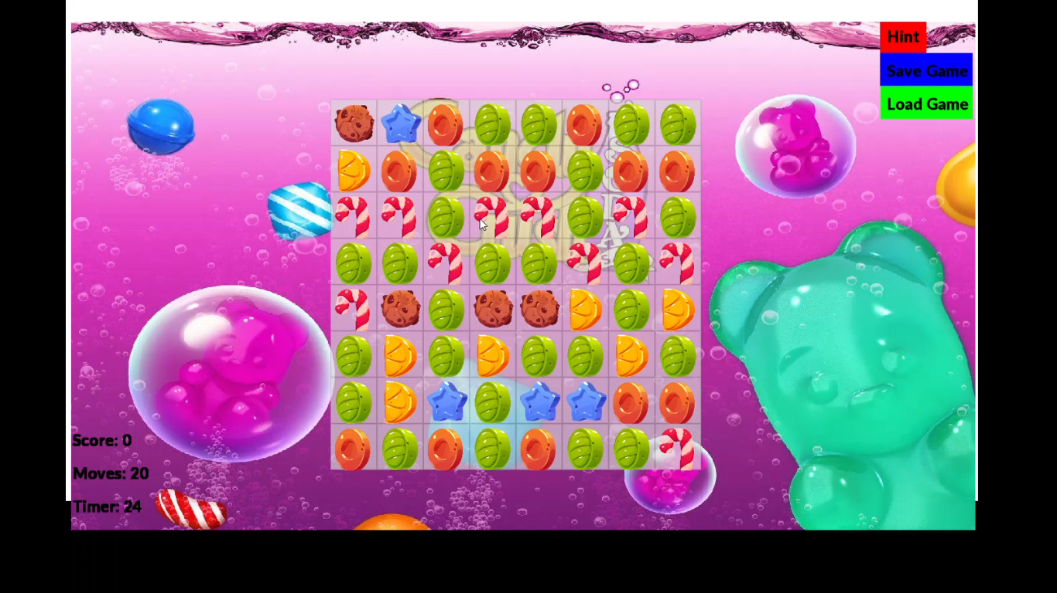

**High lightening of candy:**

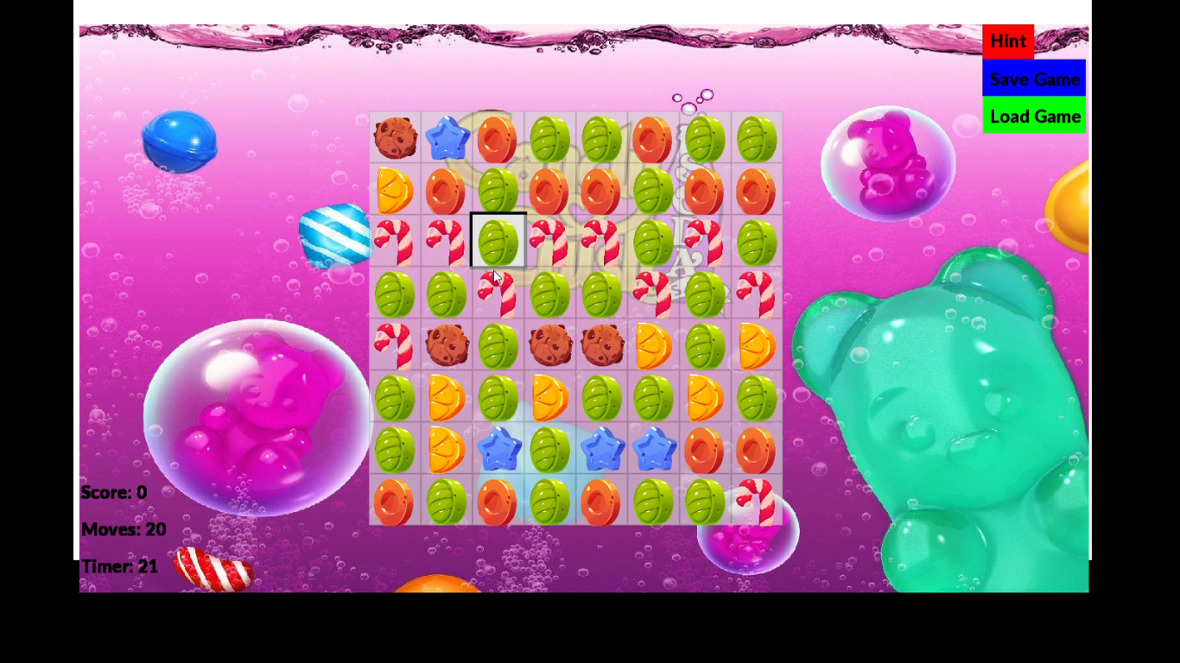

**Hint:**

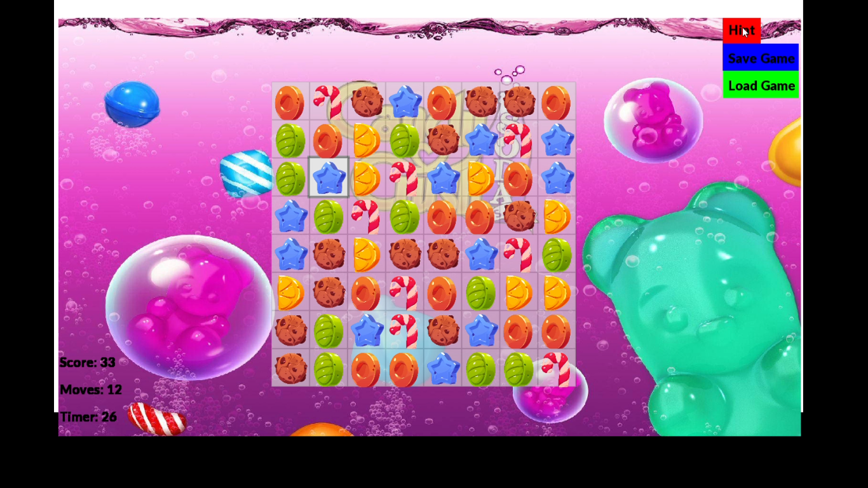

**3 same tiles Bursting of candies:**

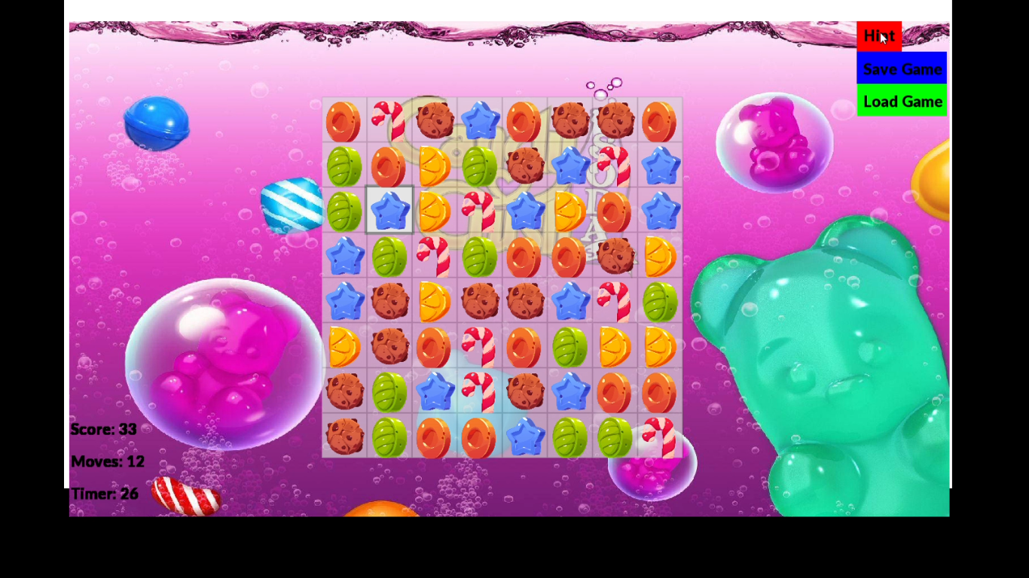

**4 same tiles combination bursting:**

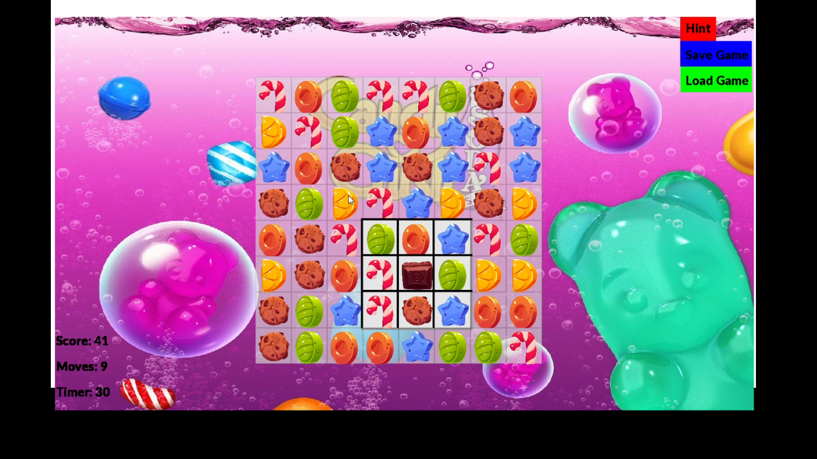

**5 same tiles combination bursting:**

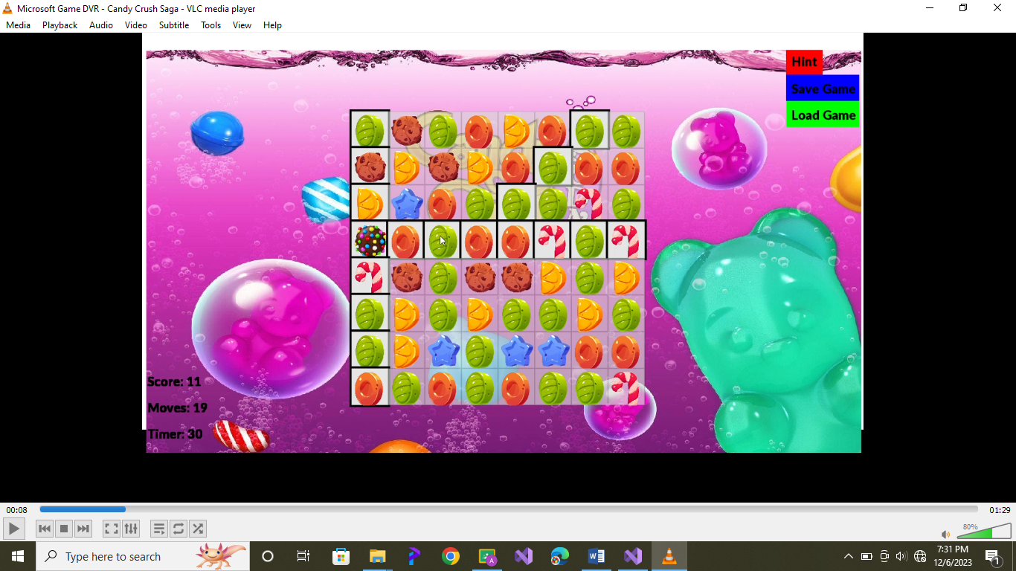

**Save game:**

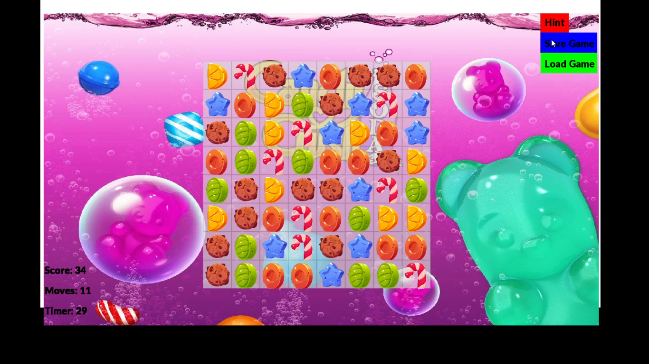

**Load game:**

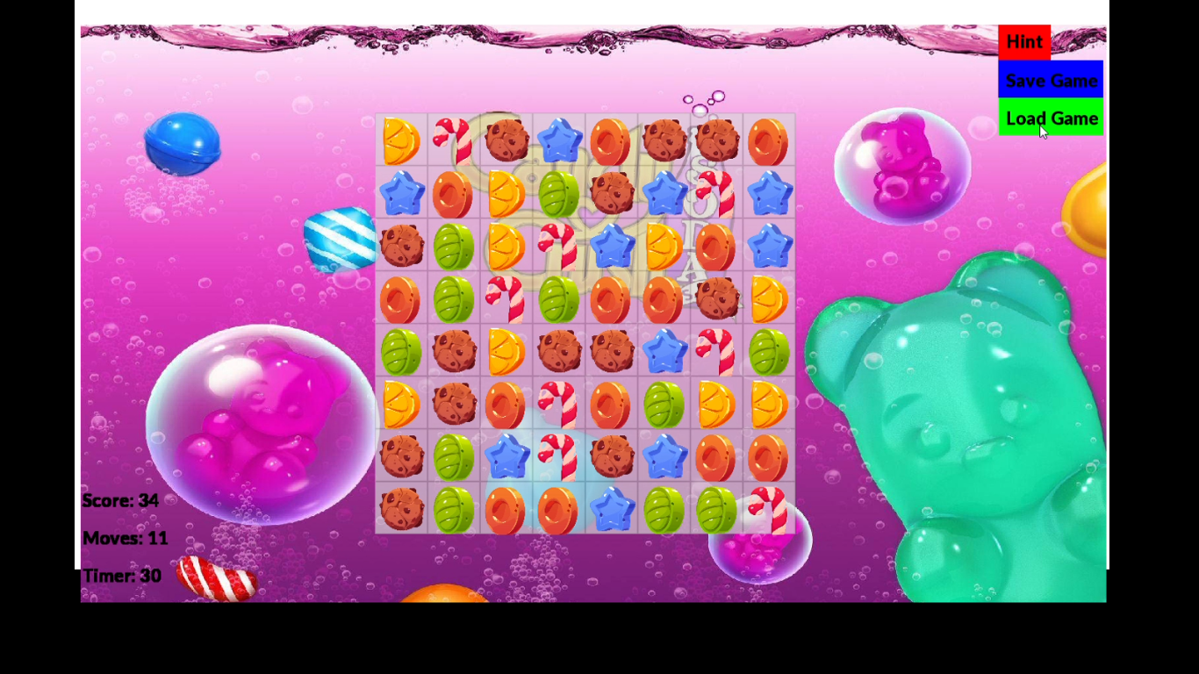

**FUNCTIONS:**

**Game loader:**

It opens or creates load.txt file. It then writes score and moves. Then keeping in view the rows and columns of grid, it writes candies positions in the file.

**Game:**

It only reads data from load.txt file. It then compares score with data. If they are same. Game saver reads score and prevscore stores this. Then with moves, it compares data. If they are also same. Game saver reads moves. If moves are less than or equal to 0. Again resets moves to 20 and score to 0.

**load texture:**

This function loads textures of png images from link I provided in code. Using loop, it loads them and assigns them numbers from 1 to 6. For loading of special candies, it uses another loop and loads them.

**Initialize grid:**

This function randomly generates candies in cells of grid of defined size. But it also keeps track of this thing that not more than 2 candies must be same either diagonally, horizontally, vertically and in elbow. It generates special candies only when specific conditions meet.

**Valid_swap:**

If three, four or five candies are same in horizontally, vertically and diagonally or in elbow condition, result is true and the function breaks. Now they are allowed to swap. Otherwise they are not allowed to swap.

**Row_col matching:**

Now, if the bursting condition of candies is true, the candies are assigned to burst. Assigned to burst is a 2D Boolean array. Then they are checked to be valid or not. This array is actually assigned false.

**Scorestext updation:**

There is character 1D array. Whenever any updation of score occurs, this function is called. It uses snprintf to format character array and helps in displaying score.

**Movestext updation:**

There is character 1D array. Whenever any updation of moves occurs, this function is called. It uses snprintf to format character array and helps in displaying moves.

**TimerText updation:**

There is character 1D array. Whenever any updation of timer occurs, this function is called. It uses snprintf to format character array and helps in displaying time.

**Isanymovevalid:**

This function checks if there is any possible move left in grid. If not, it returns false. But if true, it returns true.

**ShuffleBoard:**

This function is used to shuffle board. Shuffling only occurs when isanymovevalid returns false.

**HINT:**

This function is used to highlight the candy whose swapping results in bursting of candies. It highlights the candy.

**Samecandies_bursting:**

This function does a great job. It marks candies to -1 which have been swapped. Then it makes candies above them to take their place. It uses for loops to burst 3-by-3 region if 4 tiles combination becomes. Also it bursts whole row and column if 5 tiles combination becomes.

**Int main ():**

First it calls both load textures and initialize grid functions. Vector2f (1400.0f, 900.0f) is used to create a two-dimensional vector with an x-coordinate of 1400.0f and a y-coordinate of 900.0f. From uploading of text to creating of buttons, music to contrast light, all are uploaded and constructed using sfml before wondow. open loop. In wondow. Open loop, there are different conditions for mouse button pressed. Wherever user pushes button of mouse in grid or on window, he will receive corresponding kind of result. Then sfml draws button, text in them. There are some conditions here which I have described in readme file. Cell positon is set here. Sprite also works here. In the end, this code returns zero.